Multiple Choice

QUESTION 1
In an open chemical system
- energy but not matter is exchanged with the surrounds.
- matter but not energy is exchanged with the surrounds.
- both matter and energy are exchanged with the surrounds.
- neither energy nor matter is exchanged with the surrounds.

QUESTION 3
Which of the following is an example of a redox reaction?
- HCl(aq) + NaOH(aq) → NaCl(aq) + H₂O(l)
- 2AgNO₃(aq) + Na(s) → NaNO₃(aq) + 2Ag(s)
- AgNO₃(aq) + NaCl(aq) → NaNO₃(aq) + AgCl(aq)
- HCl(aq) + Na₂CO₃(aq) → NaCl(aq) + CO₂(g) + H₂O(l)

QUESTION 6
HF_{(aq)} + H₂O_{(l)} ⇌ H₃O⁺_{(aq)} + F–_{(aq)}
The equation above shows
(A) the transfer of hydrogen ions between conjugate acid-base pairs.
(B) the transfer of electrons between conjugate acid-base pairs.
(C) the neutralisation of an acid to produce a conjugate base.
(D) the neutralisation of an amphoteric species in solution.

QUESTION 7
Identify the oxidising agent in the following redox reaction.
2S₂O₃^{2–}(aq) + I₂(s) → S₄O₆^{2–}(aq) + 2I–(aq)

- I–(aq)
- I₂(s)
- S₄O₆^{2–}(aq)
- S₂O₃^{2–}(aq)

QUESTION 9
Predict the effect that increasing temperature will have on the following reaction.
N₂(g) + O₂(g) ⇌ 2NO(g) ΔH = +181 kJ mol^{–1}
(A) The equilibrium position will not change.
- The equilibrium position will move towards the reactants (left).
- The equilibrium position will move towards the products (right).
- It is impossible to predict the effect on the equilibrium position.

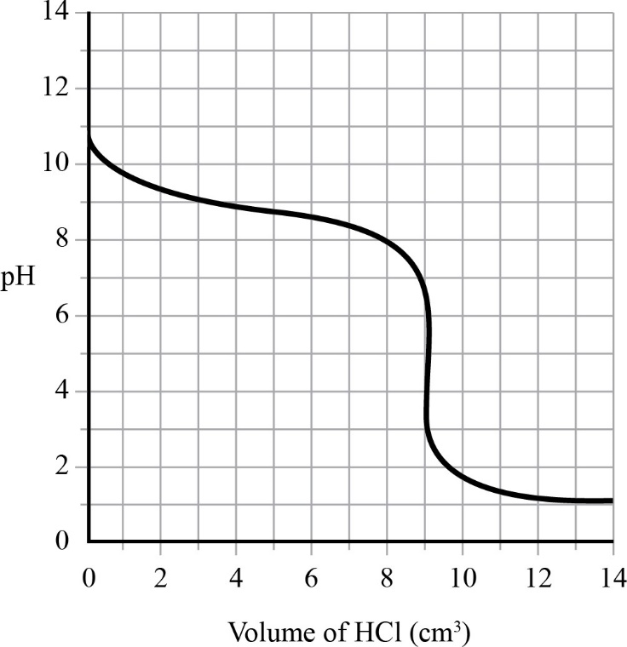
QUESTION 10
The graph below shows the pH changes during the titration of 10.0 cm³ of a weak base with
0.10 mol dm^{–3} HCl.
The initial concentration of OH– ions in the weak base is
- 10.5 mol dm^{–3}
- 3.5 mol dm^{–3}
- 10^{–3.5} mol dm^{–3}
- 10^{–10.5} mol dm^{–3}

QUESTION 14
Deduce the oxidation state of nitrogen in NO₃–.

- –5
- -3
- +3
- +5

QUESTION 16
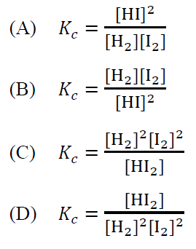
Deduce the correct equilibrium law expression for the following reaction. H₂(g) + I₂(g) ⇌ 2HI(g)

QUESTION 18
Determine the relative strength of the following oxidising agents (from strongest to weakest) by comparing standard electrode potentials.

(A) MnO₄– > Mn²⁺ > Mn
(B) Mn²⁺ > Mn > MnO₄–
(C) Mn > Mn²⁺ > MnO₄–
(D) MnO₄– > Mn > Mn²⁺

QUESTION 19
Determine the pH of a 0.15 M solution of hydrochloric acid (HCl).

- 0.15
- 0.71
- 0.82
- 1.41

QUESTION 22
Which of the following acids can be classified as monoprotic?

- H₃PO₄
- H₂CO₃
- H₂C₂O₄
- CH₃COOH

QUESTION 23
The Haber process combines nitrogen and hydrogen to produce ammonia as shown in the reaction below.
N₂(g) + 3H₂(g) ⇌ 2NH₃(g) ΔH = -92 kJ mol^{–1}
Which of the following conditions favours the formation of the highest yield of ammonia from an equilibrium mixture of nitrogen and hydrogen?

- high temperature and high pressure
- high temperature and low pressure
- low temperature and high pressure
- low temperature and low press

QUESTION 24
Acid | K_{a} (20 °C)
Acetic acid | 1.8 × 10^{–5}
Chlorous acid | 1.1 × 10^{–2}
Nitrous acid | 4.0 × 10^{–4}
Phosphoric acid | 7.5 × 10^{–3}

The table on the right shows the K_{a} value for several weak acids.
Which acid dissociates to form the strongest conjugate base at equilibrium in an aqueous solution?
- acetic acid
- chlorous acid
- nitrous acid
- phosphoric acid

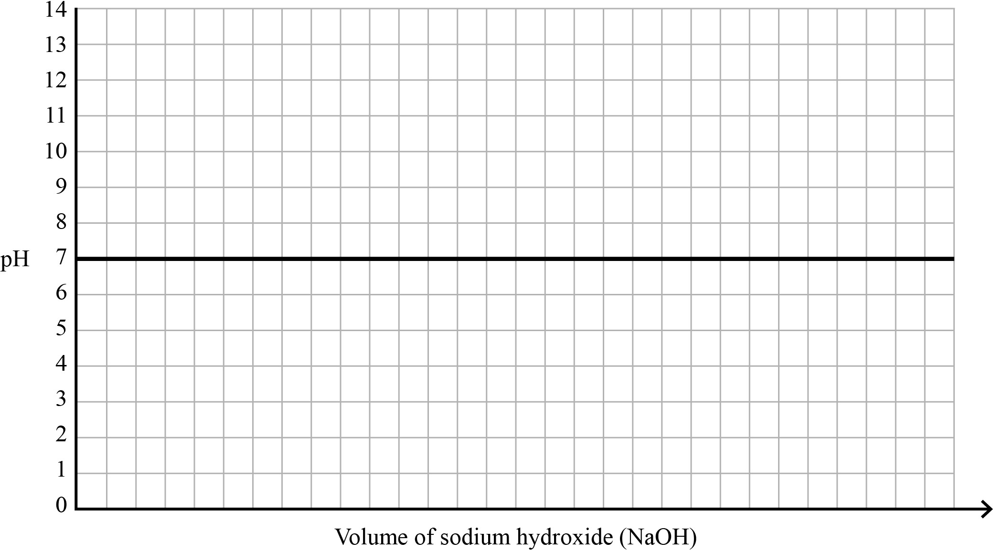
QUESTION 28 (3 marks)
On the axes below, sketch the titration curve when 0.1 M ethanoic acid (CH
₃
COOH) is titrated with
0.1
M sodium hydroxide (NaOH) and circle the:
•

initial pH of the acid
•

equivalence point
•

buffer region.
Note:
If you make a mistake in the axes, cancel it by ruling a single diagonal line through your work and
use the additional axes on page 13 of this question and response book.

QUESTION 29 (6 marks)
The contact process is an important industrial process for making sulfuric acid (H₂SO₄). This process occurs in three stages.
Stage 1: sulfur + oxygen sulfur dioxide
S(s) + O₂(g) SO₂(g)
Stage 2: sulfur dioxide + oxygen sulfur trioxide
2SO₂(g) + O₂(g) 2SO₃(g)
Stage 3: sulfur trioxide + water sulfuric acid
SO₃(g) + H₂O(l) H₂SO₄(l)
- Explain which stage of the process would be affected by a change in pressure. [2 marks]

________________________________________________________________________
________________________________________________________________________
________________________________________________________________________
- Calculate the mass of sulfur required to produce 1100 kg of sulfuric acid if the yield of sulfur trioxide in the contact process is 97%. Show your working. [4 marks]

________________________________________________________________________
________________________________________________________________________
_________________________________________________________________________
________________________________________________________________________

Mass = ____________ kg

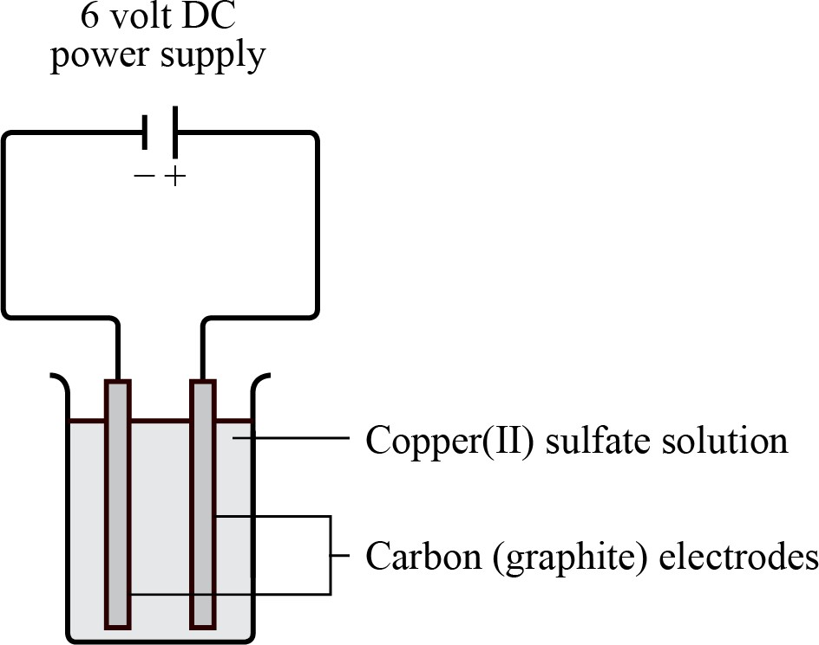
QUESTION 30 (5 marks)
The following diagram shows the electrolysis of a 0.5 M solution of copper(II) sulfate (CuSO
₄
)
.

a)

Predict the product formed at the anode.
[1
mark]

__________________________________________________________________________________
b)

Explain which product would be formed at the cathode.
[3
marks]

__________________________________________________________________________________
__________________________________________________________________________________
__________________________________________________________________________________
__________________________________________________________________________________
c)

Identify one limitation associated with the use of standard reduction potentials.
[1
mark]

__________________________________________________________________________________
__________________________________________________________________________________

QUESTION 31 (6 marks)
Phenolphthalein is an organic compound often used as an acid-base indicator. In its colourless form (H₂In) it is a weak acid that dissociates in water to form pink anions (In^{2–}).

- Determine the equilibrium equation for phenolphthalein. [1 mark]

__________________________________________________________________________________
- Identify the conjugate base in the equilibrium equation determined above. [1 mark]

__________________________________________________________________________________
- Explain why phenolphthalein does not change colour in an acidic solution when
titrated with a small amount of NaOH. [4 marks]

__________________________________________________________________________________
__________________________________________________________________________________
__________________________________________________________________________________
__________________________________________________________________________________
__________________________________________________________________________________
__________________________________________________________________________________
__________________________________________________________________________________
__________________________________________________________________________________

QUESTION 32 (5 marks)
- Calculate the concentration of hydroxide ions (OH–) at pH 12.3. Show your working. [2 marks]

__________________________________________________________________________________
__________________________________________________________________________________ __________________________________________________________________________________
Concentration = ____________ mol/L
- If 15.55 mL of a 0.10 M standardised solution of sodium hydroxide (NaOH) is required to neutralise 10.00 mL of sulfuric acid (H₂SO₄), calculate the concentration of the
sulfuric acid solution (in mol/L). Show your working. [3 marks]

__________________________________________________________________________________
__________________________________________________________________________________
__________________________________________________________________________________ __________________________________________________________________________________
Concentration = ____________ mol/L

QUESTION 33 (5 marks)
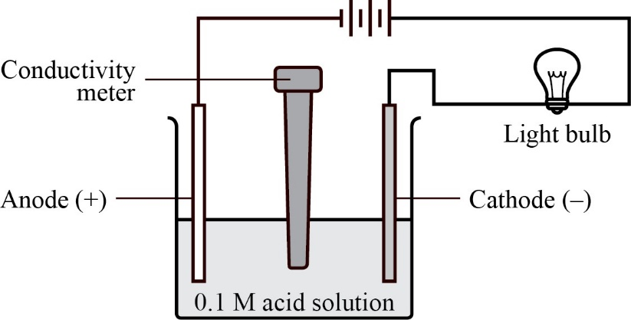
The experiment shown below was set up to investigate the relative strengths of two unknown acids. The power supply was connected to two graphite rods.
The brightness of the bulb and the electrical conductance for each acid are recorded in the table below.
Acid solution (0.1 M) | Bulb brightness | Electrical conductance  (micromho/cm) at 25 °C
A | dim | 4.2
B | very bright | 11.7
- Analyse the experimental data to determine which acid is strongest. [1 mark]
__________________________________________________________________________________
__________________________________________________________________________________
- Explain the relationship between the brightness of the bulb, conductivity and the
strength of the acids. [4 marks]
__________________________________________________________________________________
__________________________________________________________________________________
__________________________________________________________________________________ __________________________________________________________________________________

EXTENDED ANSWER QUESTIONS
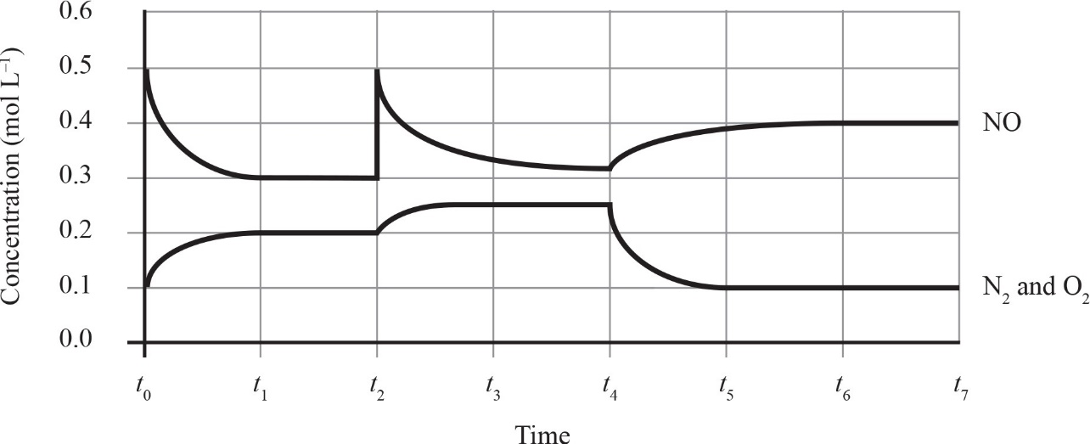
QUESTION 1 (8 marks)
The reaction between nitrogen gas (N₂) and Oxygen gas (O₂)
and oxygen gas (O
to produce nitrogen monoxide (NO) is given
by the following equation.
N
₂
(
g) + O
₂
(
g)
⇌
2NO(g)
Δ
H
= +181 kJ mol
^{–1}

When nitrogen gas and oxygen gas are mixed in a closed 1.00 L container, the concentration of each
species can be measured at regular intervals. The graph below shows how the concentration of each species
changes over time.

a)

Identify the number of times that the system establishes equilibrium between t₀ and t₇
[1
mark]

__________________________________________________________________________________
b)

Explain what effect a decrease in pressure at time t₇
would have on the position of
equilibrium. Show your reasoning.
[2
marks]

__________________________________________________________________________________
__________________________________________________________________________________
__________________________________________________________________________________
__________________________________________________________________________________

- Predict the effect that an increase in temperature at time t₇ would have on the position of the equilibrium and the value of the equilibrium constant (K_{c}). Show your reasoning. [3 marks]

__________________________________________________________________________________
__________________________________________________________________________________
__________________________________________________________________________________
- Calculate K_{c} for the above reaction when equilibrium is first established. Show
your working. [2 marks]

__________________________________________________________________________________
__________________________________________________________________________________
__________________________________________________________________________________
__________________________________________________________________________________
__________________________________________________________________________________
__________________________________________________________________________________

K_{c} = ____________

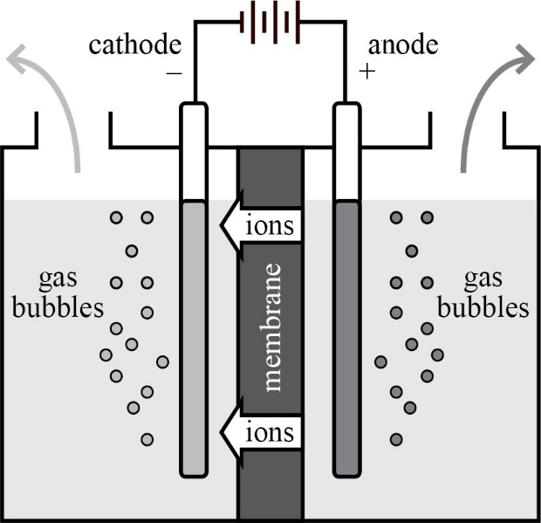
QUESTION 3 (9 marks)
The diagram below shows the structure of an electrolyser that produces hydrogen from renewable
resources. The anode and cathode are separated by a selectively permeable membrane that allows the
movement of ions.

a)

Identify the gas produced at the anode.
[1
mark]

__________________________________________________________________________________
b)

Describe the characteristic of the ions that causes them to move across the
permeable membrane.
[1
mark]

__________________________________________________________________________________
__________________________________________________________________________________

c) The diagram below represents a hydrogen fuel cell that uses hydrogen gas and oxygen gas to produce electricity.
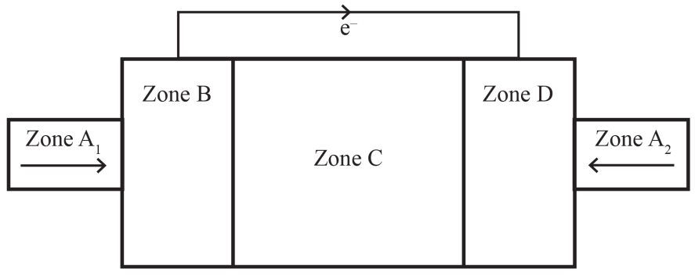
With reference to Zones A₁ and A₂, B, C and D, use the diagram above to discuss the operation of a hydrogen fuel cell with an alkaline electrolyte. [4 marks]
Zones A₁ and A₂: ____________________________________________________________________
__________________________________________________________________________________
__________________________________________________________________________________
Zone B: ____________________________________________________________________________
__________________________________________________________________________________
__________________________________________________________________________________
Zone C: ____________________________________________________________________________
__________________________________________________________________________________
__________________________________________________________________________________
Zone D: ____________________________________________________________________________
__________________________________________________________________________________
__________________________________________________________________________________

